F. EXAMPLE PROJECTS WHICH BEST ILLUSTRATE PROPOSED TEAM’S QUALIFICATIONS FOR THIS CONTRACT  (Present as many projects as requested by the agency, or 10 projects, if not specified. Complete one Section F for each project.) |  |  |  |  |  | 20. EXAMPLE PROJECT KEY NUMBER  6
21. TITLE AND LOCATION (CITY AND STATE)  California High Speed Rail, Construction Package 2 and 3  Selma, CA |  |  |  | 22. YEAR COMPLETED
 |  |  |  | PROFESSIONAL SERVICES  Ongoing |  | CONSTRUCTION (IF APPLICABLE)  N/A
23. PROJECT OWNER’S INFORMATION
a. PROJECT OWNER  California High Speed Rail Authority |  | b. POINT OF CONTACT NAME  Jorge Granados, PE |  | c. POINT OF CONTACT TELEPHONE NUMBER  (559) 385 – 7438
24. BRIEF DESCRIPTION OF PROJECT AND RELEVANCE TO THIS CONTRACT (INCLUDE SCOPE, SIZE AND COST)

Caltrans sampling and testing requirements
Immediate response from a large team of testers and inspectors
100% responsiveness to Task Orders
Day and night work
On time reporting and error free invoicing
Proven track record of success
efficient dispatch and overall management
PROJECT RELEVANCE
S2 Engineering (S2) is currently providing PCM, Materials Testing, and Lab services in Fresno County, Selma, CA. This project begins at East American Avenue in Fresno to a mile north of the Tulare – Kern County line. This project is approximately 65 miles and includes 36 grade separations such as overpasses and underpasses and viaducts in Tulare, Kings, and Fresno counties. Auxiliary features include embankment construction for the future rail line, retaining walls, roadway and utilities relocations, and appurtenant structure work.

S2 provides materials testing and plant inspection services in an oversight and independent assurance capacity. Daily functions include material testing of bridges material including high performance concrete, rebar splices, deck metals, and back fill materials. Materials testing for horizontal construction includes compaction testing for embankment construction, testing of base materials for future station structures and hardscape, source materials testing for large fill areas, and testing or erosion control materials for slopes.

S2 provides these services in a “round the clock” capacity in conjunction with the project’s oversight and CM consultants. S2 is able to document quality activities in accordance with project specific “verification and validation” procedures outlined project’s custom project quality manual. All reporting and filing are performed in accordance with the Rail Authority’s documentation procedures that are based on the Caltrans Unified Filing System.
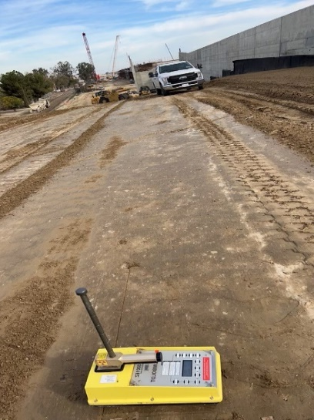
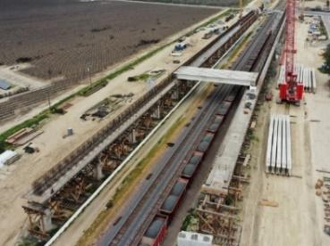
Additionally, it was found that there was no plant to construct the girders and pre-cast slabs to the required standards. Therefore, the JV determined it needed to construct an on-site Pre-Cast Facility where girders and pre-cast slabs will be manufactured. This facility will allow DFJV to make as many as eight girders at a time which will expedite the bridge making process in CP 2-3. The facility will ultimately make around 1,300 different kinds of beams and almost half a million pre-cast slabs. Smith-Emery has been instrumental in assisting the JV to make sure the facility was built to appropriate standards and make sure it received the proper and necessary certifications to get up and running in record time. We continue our involvement, providing testing and inspection at the plant for the fabrication of the pre-cast materials.
25. FIRMS FROM SECTION C INVOLVED WITH THIS PROJECT
a. | (1) FIRM NAME  S2 Engineering, Inc |  | (2) FIRM LOCATION (CITY AND STATE)  Rancho Cucamonga, CA |  | (3) ROLE  Materials Sampling and Testing
b. | Smith Emery Laboratories |  | San Francisco, CA |  | Materials Sampling and Testing

